This is my gitlab account

After creating gitlab we get this mail
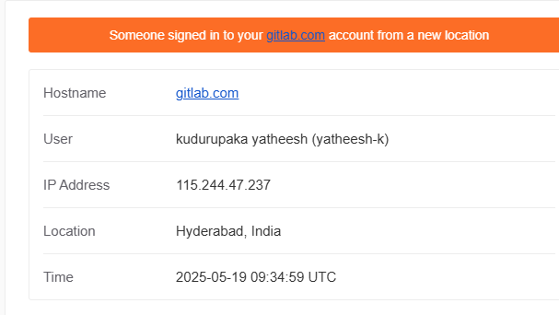

Gitlab home page,
Create new project repo,
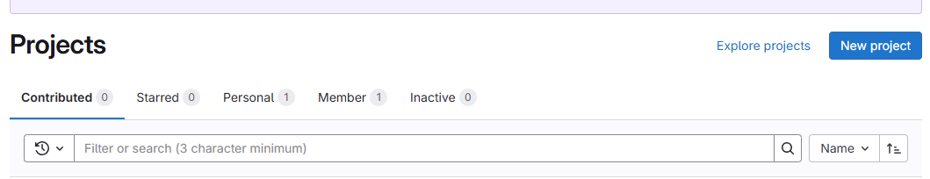

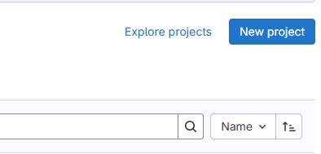

After click on new project icon we can see this page after click on create blank project,

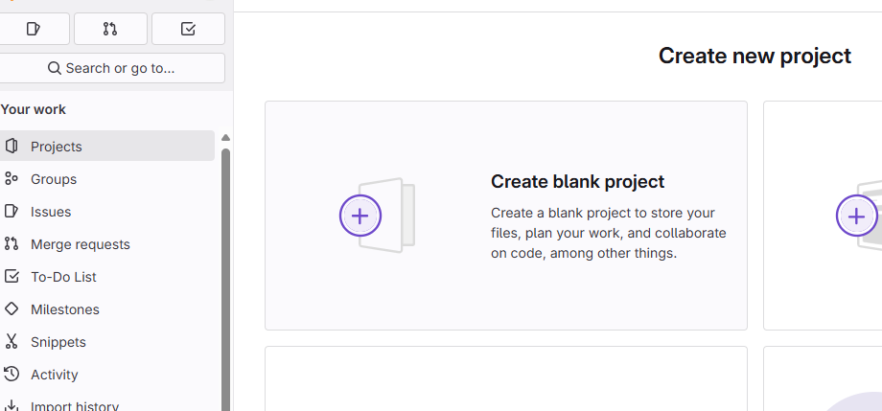

Here we can give project name,
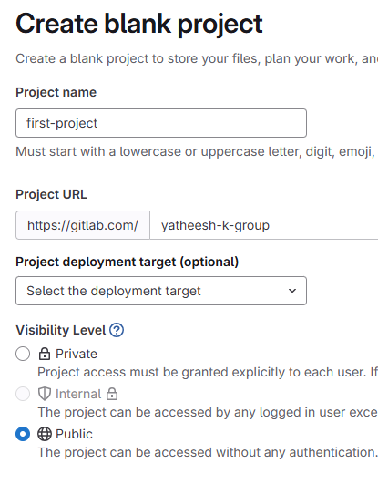

Click on create project,

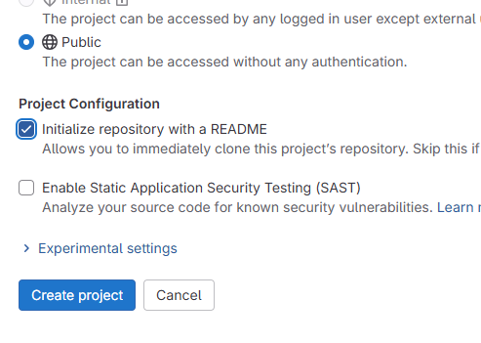

After creating repo displayed my repo like this, repo creating was completed,
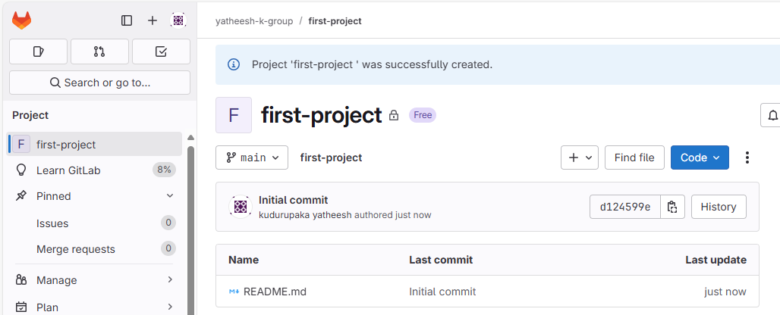

================================================================================================================================================================================================

How to push code locale to GitLab repo,

git config --global user.name "Your Name"
git config --global user.email "your_email@example.com"
git remote -v

Steps to Delete a GitLab Repository

1. Log in to GitLab
Go to https://gitlab.com and sign in.

2. Go to Your Project
Click on your avatar (top right) → "Your Projects", and open the project you want to delete.

3. Open Project Settings
On the left sidebar, scroll down and click “Settings” → then choose “General”.

4. Expand the Advanced Section
Scroll down to the bottom of the page, and find the "Advanced" section. Click “Expand” if it’s collapsed.

5. Delete the Project
- Scroll down to “Remove project”
- Click the “Delete project” button
- GitLab will ask you to confirm the project name
- Type the name exactly and confirm

🔒 Only Owners Can Delete
You must be the project owner to delete it. If you're a member with only "Maintainer" or "Developer" access, you won’t see the delete option.

